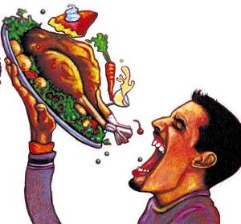**LIFE CHOICE INVENTORY**

**How well do you eat?**

**PART 1** Do you eat nutritious food from all these categories? Answer yes or no. For each yes answer, give yourself 2 points.

1. I have 2 or more cups of milk or 2 servings of milk products everyday ____



1. I have 2 or more servings of protein everyday ____



1. On some days, I eat dried peas or beans instead of meat ____
2. I generally have at least 6 servings of whole grain products ____



1. I have at least 2 servings of fruit and 3 servings of vegetables per day ____

TOTAL FOR PART 1 ____



**PART 2** Do you maintain appropriate weight? If your answer to the following question is yes, give yourself 20 points, skip part 3 and go on to part 4. If you answer no, take no points, and complete part 3 below

1. I eat just enough food to stay within 5-10 pounds of the weight considered appropriate for my height

TOTAL FOR PART 2 ____

**PART 3** Do you choose a diet low in fat, saturated fat & cholesterol?

For each yes answer, give yourself 1 point.

1. My milk and milk product choices are mostly non or low-fat ____

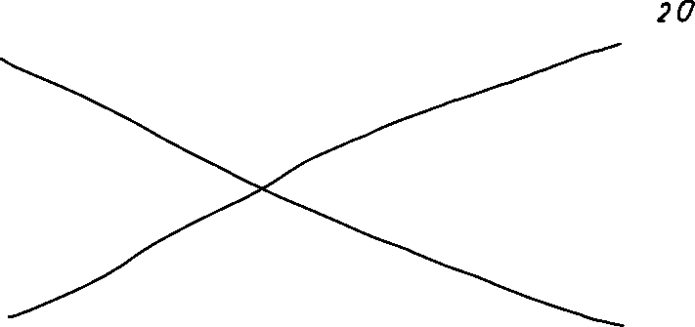

1. I seldom have more than about 3 teaspoons of butter per day ____
2. I usually have 2 servings of lean-meat, fish or eggs ____
3. I eat chicken, turkey and fish more than beef, ham or pork ____
4. I avoid eating hotdogs, sausage and fatty meats ____
5. When selecting meat, I usually choose broiled or baked, not fried ____
6. On some days I eat dried peas or beans instead of meat ____

This question is the same as #3, it counts for both sections

1. In preparing vegetables, I use little or no fat ____



1. The grain products I use are whole grain ____
2. In buying foods, I read labels ____

TOTAL FOR PART 3 ____

PART 4 Do you get plenty of starch and fiber daily? Yes = 2points.

1. When I am hungry, I choose healthy options vs junk food ____



1. The grain products I eat are mostly whole grain ____



1. I eat an abundance of fruits and vegetables ____



1. I eat salad or raw vegetables at least once a day ____
2. I eat dries peas or beans at least once a week ____



TOTAL FOR PART 4 ____



PART 5 Do you eat a reasonable amount of sugar? Yes = 2points



1. I eat sweets in a limited amount, per day ____
2. I only drink 12 ounces (1 can) of soda, juice or Gatorade, per day ____



1. I brush my teeth after eating sweets or drinking sugary drinks ____

TOTAL FOR PART 5 ____



**SCORING- Add up the total for each section and read the results**

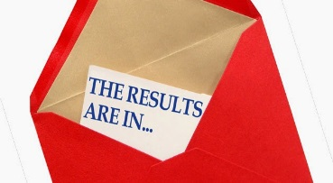50= Incredible nutritional choices

40-49= Excellent nutritional choices



30-39= Your diet has room for improvement

20-29 Not so good, work on your weakest area

Below 20= Poor nutrition, make major efforts to improve

Name: Opp:

Life choice evaluation Date:

**After completing the Life Choice Inventory, answer the following questions.**

**Use detailed and complete sentences.**

#1. How did you score on the Life Choices Inventory? Do you think that is an accurate portrayal of your eating habits? Why or why not?

I scored 42 points for the Life Choices Inventory. Which is considered to have excellent nutritional choices. I believe this is quite an accurate portrayal of my eating habits since my parents always strive for me to eat healthy food.

#2. What do you think is your biggest strength regarding your nutrition?

I think my biggest strength regarding my nutrition is that I am willing to eat anything.

#3. What do you think is your biggest issue with nutrition?

Yet, although I am willing to eat anything, I am quite picky as well. So, I am able to eat something, but I might not like it.

#4. What are three things you can do daily to improve your nutrition?

Some things I could do daily to improve my nutrition is to think before I eat, drink lots of water and try to get more vitamins from food. Maybe I could keep track of everything I eat and their nutritional values.

#5. What is one unhealthy food that you currently eat? How can you make that food a little healthier?

I believe one unhealthy food that I currently eat are pizzas. I could make that food healthier by adding on different, more healthy toppings.